Description
sqldf is an R package for runing SQL statements on R data frames, optimized for convenience. The user simply specifies an SQL statement in R using data frame names in place of table names and a database with appropriate table layouts/schema is automatically created, the data frames are automatically loaded into the database, the specified SQL statement is performed, the result is read back into R and the database is deleted all automatically behind the scenes making the database's existence transparent to the user who only specifies the SQL statement. sqldf is free software published under the GNU General Public License that can be downloaded from CRAN.
The sqldf() function is typically passed a single argument which is an SQL select statement where the table names are ordinary R data frame names. sqldf() transparently sets up a database, imports the data frames into that database, performs the SQL select or other statement and returns the result using a heuristic to determine which class to assign to each column of the returned data frame. The sqldf() or read.csv.sql() functions can also be used to read filtered files into R. 'RSQLite', 'RH2', 'RMySQL' and 'RPostgreSQL' backends are supported.

Practical Examples using Functions of sqldf()

> install.packages("sqldf")
> library(sqldf)

##Example 1
# Inserting Data Manually
Location <- "DeployID Date.Time LocationQuality Latitude Longitude

STM05-1 28/02/2005 17:35 Good -35.562 177.158
STM05-1 28/02/2005 19:44 Good -35.487 177.129
STM05-2 28/02/2005 12:49 Good -35.928 177.328
STM05-2 28/02/2005 21:23 Poor -35.926 177.314"

# Creating Table for manually inserted Data
Location.DF <- read.table(textConnection(Location), skip = 1, as.is = TRUE,
col.names = c("Id", "Date", "Time", "Quality", "Lat", "Long"))

##Example 2
install.packages("PASWR")
library(PASWR)
data("titanic3") #selecting data table
titanic3

#SELECT Statement
sqldf ("select * from titanic3")

#Using WHERE Clause
In this we are interested in knowing the number of people that are of a particular age in the data set. That would translate in my mind as selecting the count of each age listed in the titanic3 data set. A GROUP BY clause would be required to produce a COUNT(*) for each age listed. This returns a listing of results - very similar to what in RDBMS environment. In R, the information might be handled differently. Rather than having a listing that runs off the screen, we can view a histogram that reflects the entire distribution in a manner that is viewable in a small amount of space. Which can be done as below,

DF=sqldf('select age from titanic3 where age != "NA"')
hist(DF$age,data=DF, geom="histogram", col="Yellow")

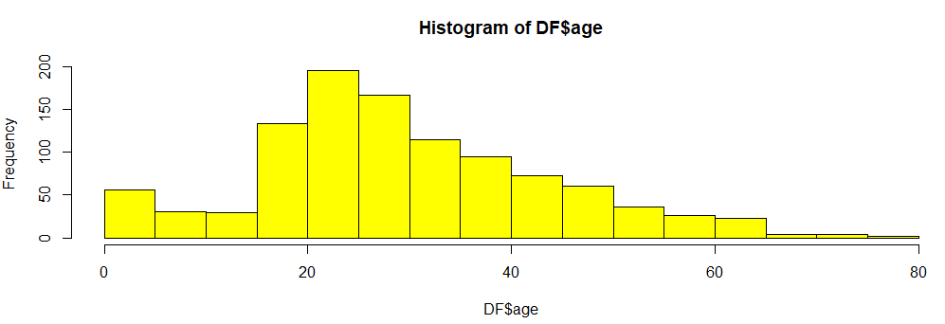

#Using GROUP BY Clause
The GROUP BY summarization using SQL is one example of a relatively straightforward summarization available using SQL. Let’s say that we are now interested in focusing in on the survival rate of 25-year olds on the titanic ship. Using the t function to perform a matrix transform which is essentially the same as producing a pivot of the original data.

DF1 = sqldf ('select * from titanic3 where age = 25 group by survived')
> DF1
total
1 23
2 11

DF2 = t(DF1)
colnames (DF2) = c ('Died','Survived')
> DF2
Died Survived
total 23 11

##Example 3
#Using LEFT JOINT
Performing joins is one of the most common operations in SQL. Left joins return all rows in the “left-hand” table - the car_manufacture set in this case, whereas right joins return all rows in the “right-hand” table - the car_details set in this case. Inner joins return only rows with matching data for the common variable, and full outer joins return all rows in all data sets, even if there are rows without matches. Currently, sqldf does not support right joins or full outer joins.
It is useful to format SQL statements with spaces and line breaks for readability and to store the query in a character string. The following statement will perform a left join of the car_manufacture data set to the car_details data set based on the common variable Car.

car_details <- read.csv("G:/SJU/7 - R Programming/week 10 Car_Details.csv",header=T)
car_manufacture <- read.csv("G:/SJU/7 - R Programming/week 10 Car_Manufature.csv",header=T)

car.leftjoin <- sqldf ("select Car, name, mpg, cylinders
from car_manufacture
left join car_details
on car_manufacture.Car=car_details.Car_sample")

head(car.leftjoin)

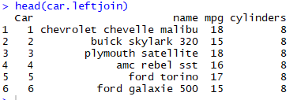

#Using MERGE Clause
The merge statement in base R can perform the equivalent of inner and left joins, as well as right and full outer joins, which are unavailable in sqldf().

car.merge <- merge(car_manufacture, car_details )
head(car.merge)

